1. Peiyun(Seed) Zeng Lu Jing

1. When put in two identical strings, only one is inserted



1. When using set<char\*> the uniqueness is disturbed

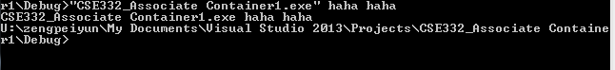

This is because haha and haha become two pointers (instead of objects) so they are different by address. That’s why they can both exist in one set

1. When using set<string> it’s maintaining a certain order, no matter what order we used to feed into the command line

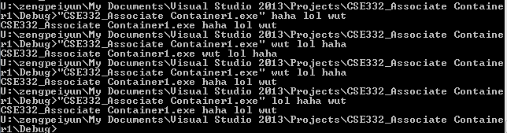

1. When using set<Char\*>, the order is exactly the same as the order we put into the command line, that’s because the address of the array is in agreement the order we unintentionally put into the command line



6.  
 